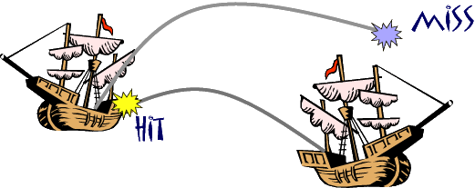







1. Draw in 2 of each boat
in your ocean.
2. Attack enemy ships by calling
a square ( Does Ken play soccer? )
3. Sink all the enemy ships to win

 | 1:15 | 8:40 | 4:15 | 5:13 | 1:50 | 7:45 | 8:14 | 4:50 | 5:30
Monday | x | x | x | x
Tuesday |  | x
Wednesday |  | x | x
Thursday |  | x | x
Friday |  | x
Saturday |  | x | 
Sunday

Are you going to the Halloween Party at __8:40__ on __Friday___?
 | 1:15 | 8:40 | 4:15 | 5:13 | 1:50 | 7:45 | 8:14 | 4:50 | 5:30
Monday
Tuesday
Wednesday
Thursday
Friday
Saturday
Sunday

